**Section 3.1—Quadratic Functions**

**Quadratic Function**—any function in the form

$$f\left(x\right)=ax^{2}+bx+c$$

**Parabola**—the graph of any quadratic function

**Vertex of a Parabola**—turning point; lowest point when it opens upward and highest point when it opens downward

**Axis of Symmetry**—the line about which a parabola is symmetric

**Standard Form of a Quadratic Equation**

$$f\left(x\right)=a{\left(x-h\right)}^{2}+k,a≠0$$

* The vertex is the point $\left(h,k\right)$.
* The parabola is symmetric about the line $x=h$.
* If $a>0$, the parabola opens upward; if $a<0$ the parabola opens downward.

**Graphing Quadratic Equations in Standard Form**

* 1. Determine whether the parabola opens upward or downward.
  2. Determine the vertex of the parabola.
  3. Find any x-intercepts by solving $f\left(x\right)=0$
  4. Find the y-intercept by computing $f\left(0\right)$
  5. 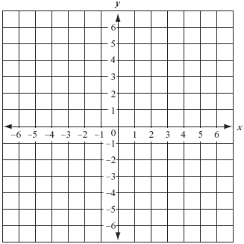Plot the intercepts, the vertex, and any additional points as needed. Connect the points with a smooth curve.

**Example**—Graph the quadratic function $f\left(x\right)=-{\left(x-1\right)}^{2}+4$.

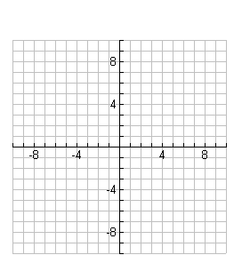**Example**—Graph the quadratic function $f\left(x\right)={\left(x-2\right)}^{2}+1$

**Vertex of a Parabola with Equation $f(x)=ax^{2}+bx+c$**

$$\left(-\frac{b}{2a},f\left(-\frac{b}{2a}\right)\right)$$

We can still use the same 5 steps to graph a parabola in this form. The only difference is how we find the vertex.

**Example**—Graph the quadratic function $f\left(x\right)=-x^{2}+4x+1$. Use the graph to determine the domain and range.

**Minimum and Maximum: Quadratic Functions**

Consider the quadratic function $f\left(x\right)=ax^{2}+bx+c$

1. If $a>0$, then f has a minimum that occurs at $x=-\frac{b}{2a}$. This minimum value is at $f\left(-\frac{b}{2a}\right)$.
2. If $a<0$, then f has a maximum that occurs at $x=-\frac{b}{2a}$. This minimum value is at $f\left(-\frac{b}{2a}\right)$.

In each case, the value of x gives the location of the minimum or maximum value.

**Example**—Using $f\left(x\right)=4x^{2}-16x+1000$, complete the following.

1. Determine, without graphing, whether the function has a minimum value or maximum value.
2. Find the maximum or minimum value and determine where it occurs.
3. Identify the domain and range.

**Example**—The function $f\left(x\right)=.4x^{2}-36x+1000$ models the number of accidents, $f\left(x\right)$, per 50 million miles driven, for drivers x years old, where $16≤x≤74$. What is the age of a driver having the least number of car accidents? What is the minimum number of car accidents per 50 million miles driven?